VOGELTOWN BOARD OF TRUSTEES
Care for the land - Care for the people - Go forward
Manaaki whenua - Manaaki tangata - Haere whakamua

MINUTES - MEETING NUMBER 4
Date: | 13/06/2023 | Meeting opened: | 6.00pm
Present: | Jeremy Ogle, Mike Miners, Peta Apperley,, Paul Gibbins, Hemi Coates, | Apologies: | Rachel Pretty, Steve Venables

CORRESPONDENCE IN
DATE: | FROM: | RE: | DISTRIBUTED TO:
16/06/23 | Staples Rodway | Audit | MIke Miners

CORRESPONDENCE OUT
DATE: | FROM: | RE: | DISTRIBUTED TO:
01/06/23 | Mike Miners | ERO | Alisha

 | ITEM: | PARTICULARS: | Forwarded | Seconded
 | Previous  New Matters Arising | Confirmation of previous meetings minutes: Ratified to go on website  Matters arising:  Health & Safety Policies were looked at, changes were made as/if required. Jeremy spoke to the staff about how serious it is to have every item correct before leaving the school grounds on a trip. RAMS forms updated. Hemi is to join the staff one morning to reiterate the importance of the H & S Policies and cross check every detail.  Support Staff Day this week. Jeremy appreciates all the Teacher Aides he has at the school, they do a great job.  If possible he would like to arrange a morning tea/lunch for them.  Rm 1 - Hopefully Room 1 can start to be rebuilt soon. Jeremy & Paul have had a meeting with builders and hopefully this is going to start.  Mike Miners will be away from 28th June to 04th August. Nominations for Steve were agreed. Mike will consult for him to step up. | Mike | Jeremy
STRATEGIC REVIEW | Monitoring | Strategic Review -  - Strategic Plan - Our team leaders will attend the board meeting at the beginning of each term.  - A survey needs to go out to the community. The questions to be asked are:  How are we going to get this out to the community? Survey Monkey?  A discussion developed around what the questions should be, are people over getting open ended question surveys, how are getting the survey out to the community?  Decision was made to use a sliding scale for the questions and that the survey is to go on as many domains as possible..  Hopefully we will get a better response than other years.  - A new Strategic Plan will be put in place for 2024. The members suggested that the SMARTER rules be put in place.  S - Specific, M - Manageable A- Achievable R-Relevant, T- Timebound, E- Engaging, R- Rewarding
REGULAR REVIEW | Targeted Reporting | From Principal’s report -  Link to Principal’s Report:  Principals Report  Roll is at 385  - 385 - We advertised for Out of Zone New Entrant children to start for the July intake. We did not get any, however we have had a couple of walkins for New Entrants.  - Mr Ogle will apply for more staffing as our Junior number increases. He will continue to do this as the next two terms go along.  - Special Needs Children  C1 - is doing well. Mum has just found out that he will require surgery for his hips as they keep dislocating. Parents are very worried about the op.  C2 - Our T.A. Mitchell is doing a great job. Unfortunately C1 is not progressing as well as hoped, he is not using the core board and has been biting the T.As. This has happened more than once or twice. A meeting is set up with the parents.  C3 - This child is a runner. We really require fencing on the Senior side of the school..  - Attendance has been lower in the last few weeks with sickness. We have had one of our families that were not attending and Nicky from truancy stepped in, now back at school.  - Book audits - Teachers have had the children's classroom book audited. Lots of writing happening across all levels and children really seem to be enjoying it. Maths books are very messy but this shows the kids working out the problems. We would prefer to have the questions at the top of the page and working outs across the bottom.  - Julie is doing a great job with our reading recovery kids. They are always happy to join her groups.  - ERO - Cath met with Jeremy to go over information about our learners profiles and values of the school. It was decided that a tool would be put together to help the children understand the values better. We are going to use the ‘Whare tapa wha model’ as the base and build on it. Jeremy has put together a rough plan of what he would like.  Staff have come up with a few questions to help children start.  Our next staff meeting will be based around this draft.  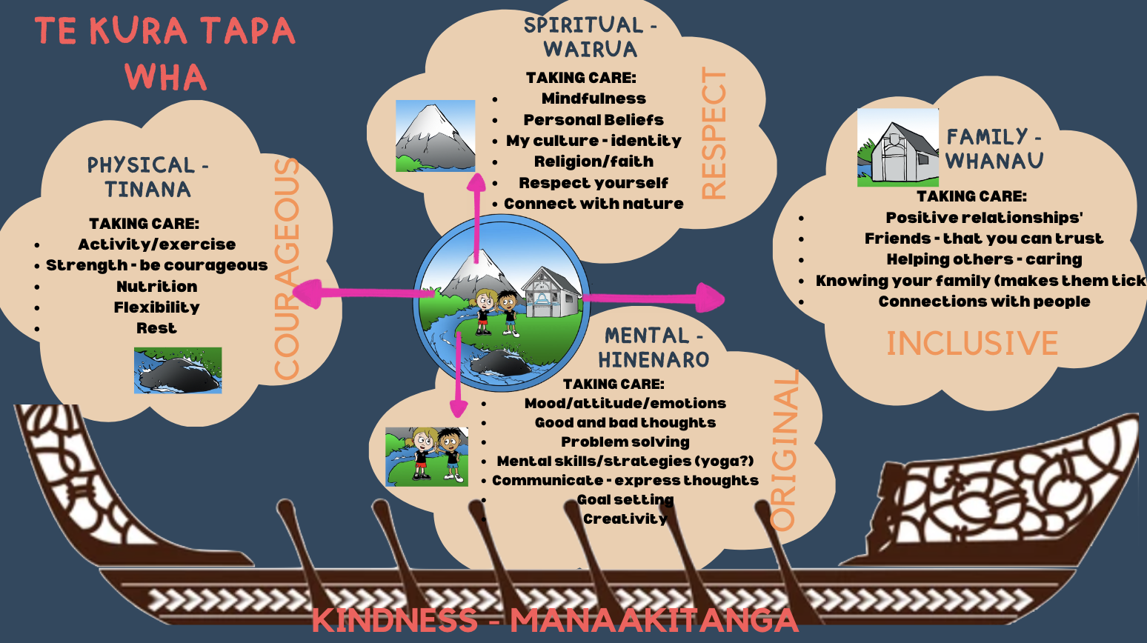  - Satisfaction survey has been completed with great feedback.  All the teachers love reading the community's feedback. Mr Ogle takes all feedback good or bad and looks at what changes he can make to better the school. The board members were very proud of Jeremy and his team of teachers.  - Kahui Ako - Laura Seed travelled to Levin to meet other groups from around the lower North Island. They spoke about wanting coherent pathways. They have researched the trend and facts which result in coherent pathway transitions. Laura is working closely with Highlands Intermediate which is our larger feed in school. The team is also looking at the attendance of children and working around the barriers for young children to attend school.  Welbourne School is requiring a Kahui Aho to join the group but Highlands Intermediate, Puketapu, NPGHS, NPBHS are all involved.  The Board has concerns about the groups goals and targets as nothing has been set for them, they seem to be making it up as they go along which is not ideal. Questions were asked as to how this is benefitting the school? Are there any regions doing it well?  The board members would appreciate Ngati coming in to help them have a better understanding.
 | Property Report | Shane’s Report for the Board.  Shanes Report  - Junior School roof repairs are to start soon. WSP are in the process of sorting out who has won the contract.  - Senior admin block is to be measured for upgrade to have designs drawn up.  - Room 1 will hopefully start to be rebuilt. We are still waiting on any financial payment from the Insurance company.  - Shane’s jobs - Basketball hoops have been removed and new ones installed. Inter School games at Vogeltown have been completed. More info see Shanes report.  - Playground checks have been completed. All good to go.  - Rm 12 floor is feeling very spongy, needs to be repaired or replaced
 | Personnel | - T.A. Teresa Corlette is working with us until the end of 2023.  - Mike George away Term 3 & 4  - Laura Matthews leaving end of this Term  - Lisa Sawtell is pregnant, will be on leave Term 4  - Vogeltown has a lot of T.A staff, 13 pax 4 on the Senior side and 9 on Junior side.  Laura Seed meets with the T.A.s every Monday morning and Lee Newland meets Junior side teacher aides every second week as well. The new shared google doc seems to have helped with communication between staff.
 | Financial report | - Finance reports passed  - Great feedback from the audit. We have come in on budget and are adhering to all policies, which takes great work from the whole team.  Audit results will be put on the Vogeltown website  - We are getting new quotes for cameras around the school, apparently it will be the wiring that will cost the most. | Mike | Hemi
 | Health & Safety | Hemi Coates went through the Policies that require review thoroughly.  - Personal Digital Devices - Phone and watches are to be handed in every morning to the office. A parent questioned this policy as watches can be put on school mode. Unfortunately children can take it out of school mode anytime so they must be handed in
 | Admin | BOT minutes will be placed on the website, approved | Mike | Jeremy
EMERGENT  REVIEW | Upcoming reviews | - School Docs review
 | Meeting review | How did we go at this meeting?  All good! Thank you to Jeremy for a thorough report.  Next Meeting  Tuesday 08th August 2023, 6.00pm
 | Meeting closed | 8pm

